|  |  |
| --- | --- |
| *Pacific Gas and Electric Company* | |
| Release 9.7.3 Installation Guide | |
|  |  |
|  |  |
| Project | ED AM/GIS |
|  |  |
| Prepared by | Subhankar Baidya |
| Date | 8/26/2015 |
| Version | 1.0 |
| Version Type | Draft |

|  |  |  |  |
| --- | --- | --- | --- |
| Revision History | | | |
| Document # | Date | Author | Summary of Changes |
| 1.0 | 8/10/2015 | Rob Rader | Initial Document Creation |
|  |  |  |  |

# Introduction

## Purpose

This document is intended to detail the implementation and configuration steps required to implement Release 9.7.2 Installation Guide. This document describes the various configuration aspects required to complete any manual or automatic patch associated with this release. Each section in this document contains the steps required to patch the system in production.

## Terms Used

|  |  |
| --- | --- |
| OOTB | Out of the box. Unmodified from the commercial version. |
| TFS | Team Foundation Server |

## External Documents

Referenced are any external configuration documents or exports. These are documents that contain more detailed information about configuring a system or documents that can be loaded into an application to perform the configuration detailed in this document.

1. Supporting documentation folder
   1. **TFS documentation location:**

$/EDAMGIS/Source_Development_10_2_1/Documentation/Data Model/Release Documentation/EDER/9.7.3

## List of Fixes

Below is the list of change requests detailing all fixes for the data model for this release:

|  |  |
| --- | --- |
| **Item Number** | **Title** |
| [23365](http://edappgistfsprd1:8080/tfs/ElectricDistCollection/EDAMGIS/_workitems#_a=edit&id=23365) | Master TFS DM 9.7.3 |
| [23363](http://edappgistfsprd1:8080/tfs/ElectricDistCollection/EDAMGIS/_workitems#_a=edit&id=23363) | Apply ACTUALDUCTSIZE model name so x-section header has correct size value |
| 23386 | Assign combo AU to the DC/Neutral and Deact->Conduit relationship classes |
| [23383](http://edappgistfsprd1:8080/tfs/web/wi.aspx?pcguid=15e9a9d1-95cb-4dd0-abfe-5af14ae6201f&id=23383) | Apply Circuit Color SQL Update Script |
| [23394](http://edappgistfsprd1:8080/tfs/ElectricDistCollection/EDAMGIS/_workitems/edit/23394) | Assign AUs in Network Protector Feature Class for subtype – Network Protector |
| [23427](http://edappgistfsprd1:8080/tfs/ElectricDistCollection/EDAMGIS/_workitems#_a=edit&id=23427) | Update feeder manager AU’s on the Primary UG Conductor |
| [23385](http://edappgistfsprd1:8080/tfs/ElectricDistCollection/EDAMGIS/_workitems/edit/23385) | Create Bay Area / Northern Region Polygon |
| [23430](http://edappgistfsprd1:8080/tfs/web/wi.aspx?pcguid=15e9a9d1-95cb-4dd0-abfe-5af14ae6201f&id=23430) | Add Division and District to NetworkProtector |

Contents

1 Introduction 3

1.1 Purpose 3

1.2 Terms Used 3

1.3 External Documents 3

1.4 List of Fixes 4

2 EDGIS 6

2.1 Open a Database Connection in ArcCatalog 6

2.2 23363: Apply ACTUALDUCTSIZE model name so x-section header has correct size value 7

2.3 23386: Assign Combo AU to the DC/Neutral and Deact->Conduit Relationship classes 8

2.4 23383: Apply Circuit Color SQL Update Script 9

2.5 23394: Assign AUs in Network Protector Feature Class for subtype – Network Protector 10

2.6 23427: Update feeder manager AU's on Primary UG Conductor 14

2.7 Update Data Model Version Table 15

3 Known Issues 16

# EDGIS

## Open a Database Connection in ArcCatalog

1. Open ArcCatalog.
2. Within the Catalog Tree, expand “Database Connections” and open the active connection for this process. This is the connection that is referenced in the change request associated with this document (<DB name>). If this connection does not exist, create the connection as the EDGIS user and alter the name to the format specified.

## 23363: Apply ACTUALDUCTSIZE model name so x-section header has correct size value

1. Right click on the **DUCTDEFINITION** table in the root dataset and select **ArcFM Properties Manager**
2. Select the **Field Model Names** tab
3. Select the **ACTUALSIZE** field
4. Assign the **ACTUALDUCTSIZE** field model name from the **Electric Field Model Name** domain to the **ACTUALSIZE** field

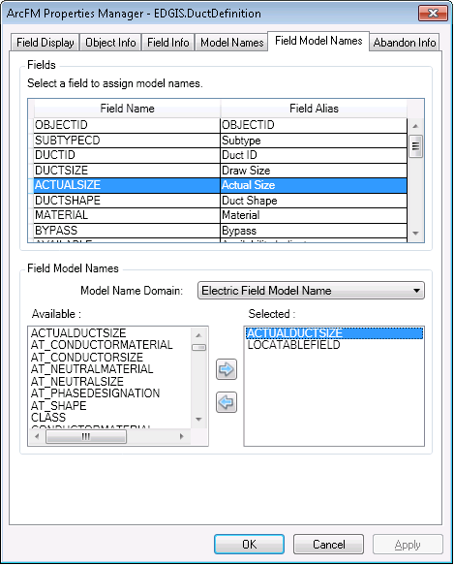

1. Click **OK**

## 23386: Assign Combo AU to the DC/Neutral and Deact->Conduit Relationship classes

1. Right click on the **ConduitSystem_DCConductor** relationship class in the Electric dataset and select **ArcFM Properties Manager**
2. Replace the On Create, On Update and On Delete events to use the **PGE LabelText Symbol Number Combo AU** in place of the ArcFM Conduit to Conductor Composite AU.

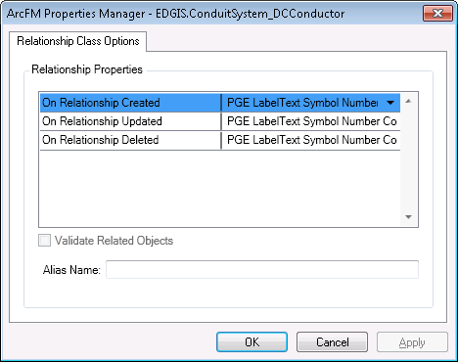

1. Click OK
2. Repeat steps 1-3 for the **ConduitSystem_DeacElecLineSeg** relationship
3. Repeat steps 1-3 for the **ConduitSystem_NeutralConductor** relationship

## 23383: Apply Circuit Color SQL Update Script

1. Open a command prompt and execute the below SQL script with the following command on the target database:  
   sqlplus edgis/<edgispassword>@<targetdatabase> @update_circuitsource_colors.sql  
     
   Link to SQL script: [http://edappgistfsprd1:8080/tfs/ElectricDistCollection/EDAMGIS/_versionControl#path=%24%2FEDAMGIS%2FSource_Development_10_2_1%2FDocumentation%2FData+Model%2FRelease+Documentation%2FEDER%2F9.7.3%2Fupdate_circuitsource_colors.sql&_a=contents](http://edappgistfsprd1:8080/tfs/ElectricDistCollection/EDAMGIS/_versionControl#path=%24/EDAMGIS/Source_Development_10_2_1/Documentation/Data+Model/Release+Documentation/EDER/9.7.3/update_circuitsource_colors.sql&_a=contents)
2. Copy the output to a log file, name it “circuit_color_output.log” and attach it to the TFS ticket for this request.

## 23394: Assign AUs in Network Protector Feature Class for subtype – Network Protector

1. Open ArcCatalog with EDGIS user. Navigate to ElectricDataset 🡪 NetworkProtector.
2. Right click on it. Select “ArcFM Properties Manager”. Go to Object Info tab.
3. Select Network Protector at the Subtype dropdown.
4. Select <Multiple…> at “On Feature Create”.

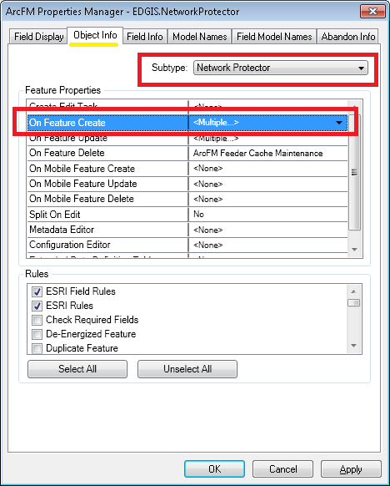

1. Add following AUs

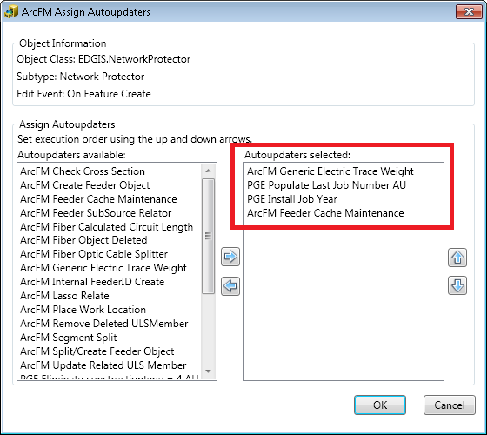

1. Click OK. Click Apply.
2. Select <Multiple…> at “On Feature Update”.
3. Add following AUs

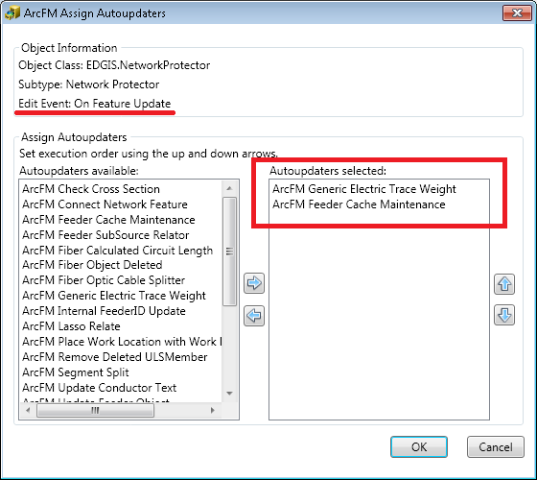

1. Click OK. Click Apply.
2. Add following AU at “On Feature Delete”.

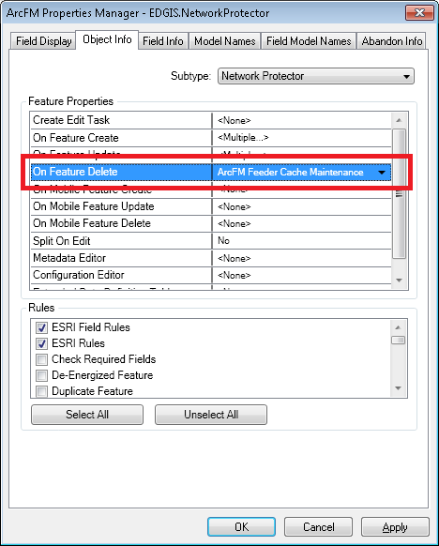

1. Click Apply. Click OK.

## 23427: Update feeder manager AU's on Primary UG Conductor

1. Right click on **PriUGConductor** in the Electric dataset and select **ArcFM Properties Manager**
2. Select the **Object Info** tab
3. Select the **On Feature Update** event and click **Multiple**
4. Remove the **ArcFM Update UG Feeder Object** AU from the list of selected AUs on the right
5. Add the **ArcFM Generic Electric Traceweight** AU from the list of available AUs on the left
6. Move the **ArcFM Generic Electric Traceweight** AU to the top of the list so that it is fired first

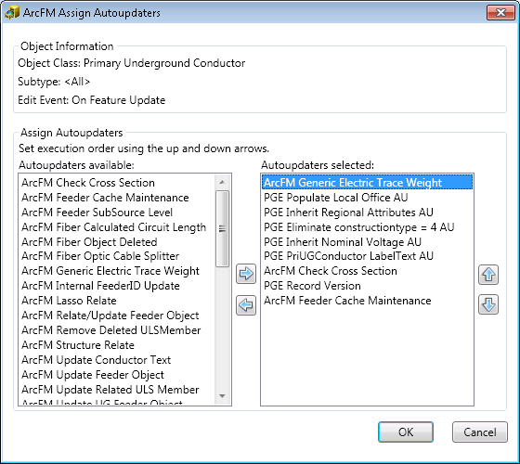

1. Click **OK**

## [23385](http://edappgistfsprd1:8080/tfs/ElectricDistCollection/EDAMGIS/_workitems/edit/23385): Create Bay Area / Northern Poly

1. Follow instructions in:

"\\sfetgis-nas01\sfgispoc_data\ApplicationDevelopment\IBM_Delivery\10.2.1\Releases\WEBR\EDVIEWER_v3.7.0\copy_bay_area_northern_poly.txt"

## 23430: Add Division and District to NetworkProtector

1. Add the Division and District fields to the NetworkProtector feature class.
   1. Double click the feature class.
   2. In the Fields tab, scroll to the bottom and click the empty field space at the end.
   3. Add two fields, with the following specifications:

DIVISION

Alias: Division

Type: Short

Allow Nulls: Yes

No default value

Domain: Division Name

Precision: 5

DISTRICT

Alias: District

Type: Long

Allow Nulls: Yes

No default value

Domain: District Name

Precision: 10

* 1. Click OK to accept.

1. Set the following ArcFM Properties:
   1. Right click the feature class and select ArcFM Properties Manager.
   2. In the Field Info tab, select the appropriate field and assign the below properties.

Division - Visible = No, Editable = Yes, Allow NULLs = Yes, Mass Attr. Update = No

District  - Visible = No, Editable = Yes, Allow NULLs = Yes, Mass Attr. Update = No

1. Assign the following field model names:
   1. Select the Field Model Names tab and select the target field.
   2. Select the PGE Electric Field Model Names domain from the dropdown in the bottom and assign the following model names.

Division - PGE_DIVISION, PGE_INHERITDIVISION, PGE_LOCATOR_DIVISION

District - PGE_DMSFIELD, PGE_INHERITDISTRICT

1. Assign the following class model names to Network Protector:
   1. Select the Model Names tab.
   2. Select the PGE Object Class Model Names domain.
   3. Assign the below model names.

PGE_VALIDATEREGIONALATTRIBUTES, PGE_ENFORCE_REGION

1. Assign the following AUs:
   1. Select the Object Info tab.
   2. Select the dropdown for the appropriate event (create, update) and click <Multiple…>.
   3. Assign the below AUs.

On feature create: PGE Inherit Regional Attributes AU

On Feature Update: PGE Inherit Regional Attributes AU

1. Assign the following QA/QC rule:
   1. In the Object Info tab, click the checkbox next to ‘PGE Validate Regional Attributes’. Scroll down in the ‘Rules’ list to locate it.
2. Click OK to apply.

## Correct Circuit Color Action Handler for GDBM

1. Open the batch server for the environment.
2. Open ArcFM Geodatabase Manager Admin.
3. Select the posting service for the Electric database.
4. Expand ‘Electric Distribution Post’ and expand ‘Before Post’.
5. Select the PGE Circuit Color action handler
6. Enter the following name for the action handler: ‘PGE Circuit Color and Feeder Type’.
7. Select the ‘PGE Circuit Color and Feeder Type Updater’ for the Action Handler field.  
   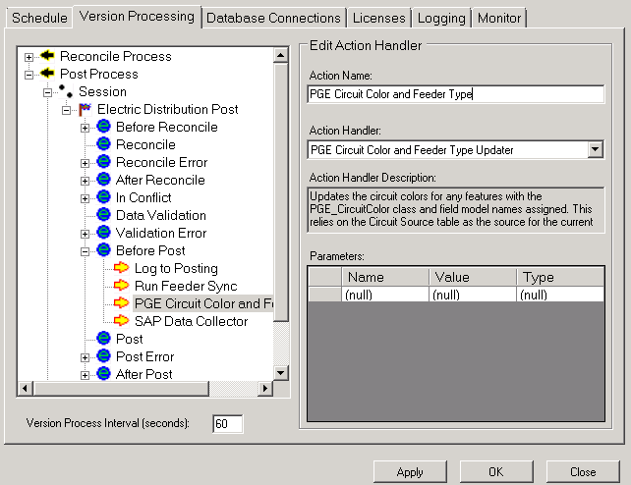
8. Click Apply.

## Update Data Model Version Table

**Database Configuration:**

1. Open SQL Plus.
2. Log in using the same server and user as was used in section 2.1.  
     
   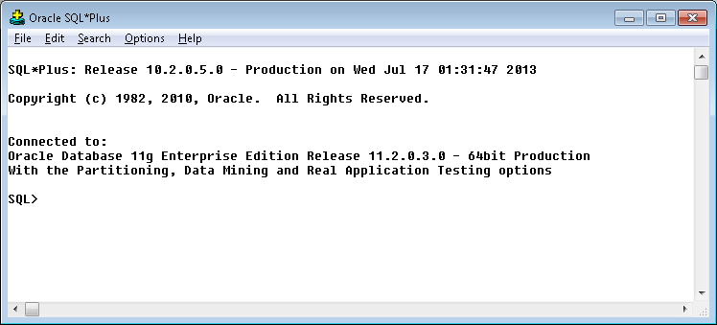
3. Run the SQL below:

update pgedatamodelversion set currentidc='N' where currentidc='Y';

insert into pgedatamodelversion (OBJECTID, CURRENTIDC, DATEAPPLIED, APPLIEDBYPERSONNAME, MODELVERSION) values (**95**,'Y',sysdate,'**Ashish**','**9.7.3** GOLD');

 commit;

# Known Issues

<Please List any other issues encountered here while following the document>